How to Access Oxford Owl

Oxford Owl is a very useful website that we recommend you use at home. It has advice on how to support your child with phonics, a selection of maths games to play and also a range of ebooks to read. Follow these simple steps to access Oxford Owl at home.
- Log on to www.oxfordowl.co.uk

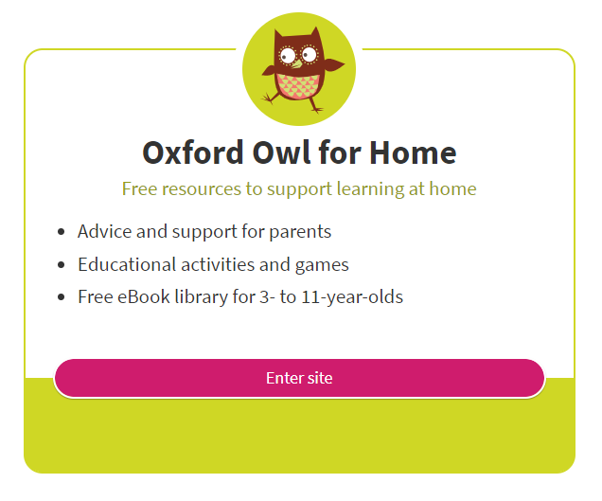
- On the home page scroll down and you will see Oxford Owl for Home. Click on ‘Enter site’.

- Scroll down to find the two sections of ‘Phonics guide’ and ‘Maths games’.

In the maths games section you can select on age 4-5 and support your child with the fun learning games. Feel free to select games in the younger or older category if you feel that your child needs more support or challenge in a particular area.

The phonics guide has some excellent videos on how to support your child to read using phonics. It also has an audio guide demonstrating how to pronounce all the sounds correctly and how to sound talk and blend the sounds together.
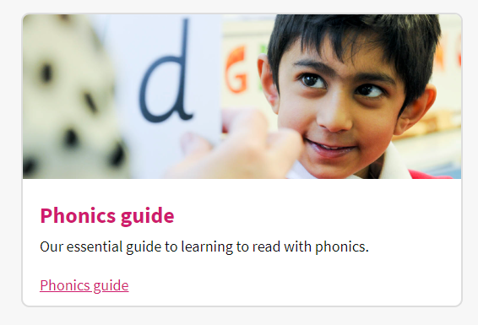
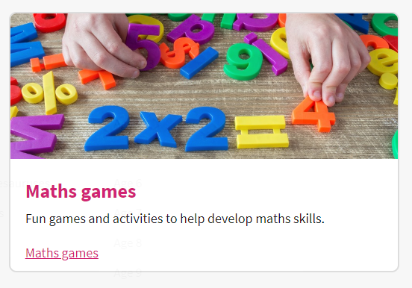

Accessing Ebooks

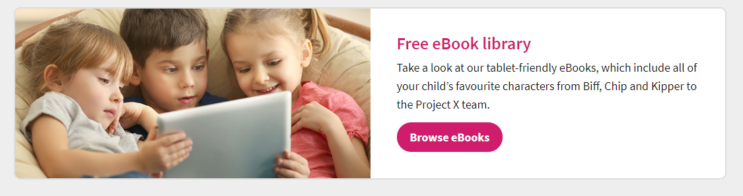
- On the Oxford Owl for Home home page click on ‘Browse eBooks’.

- Click on ‘Browse the eBook library’.
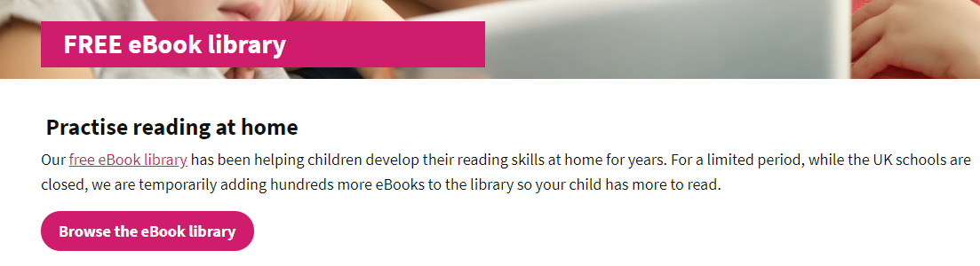

- You will be taken to the eBook library where you will then need to register to access the books. It is quick and easy to do and once completed they will send you an email to confirm your registration. The link then takes you directly to the ebook library.
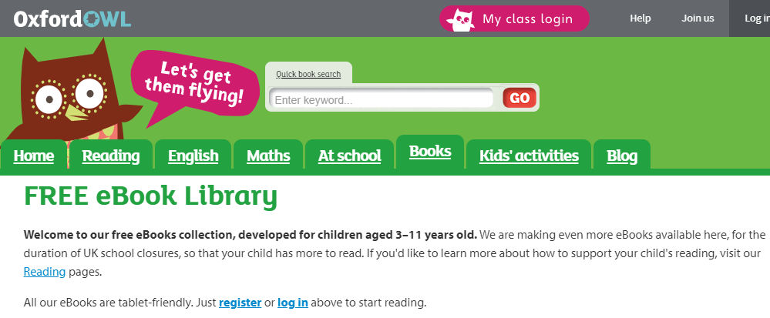

- Once you are logged in you can access all the eBooks. We recommend selecting Levels – Book band – and the colour book band that your child was on. If you are unsure then start on the lowest book band and work up to where you feel they are able to read with only a little challenge. We want them to succeed and feel confident when reading.
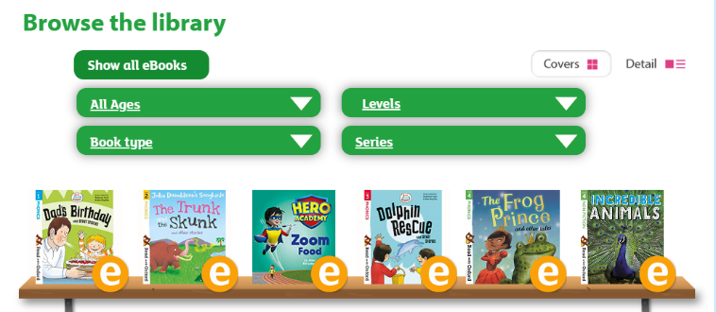
Most children will be on either pink, red or yellow book band.

We hope you find Oxford Owl helpful. If you have any questions then please feel free to contact the school or contact through tapestry.

