 **Practical Ideas**

**Baking at Home**



You could try lots of different recipes with your family. A favourite is always cupcakes and biscuits! The best part is taste testing after you have made them!

Remember to stay at home and to stay safe!

We all miss you and cannot wait to see your happy faces again when we are back at school!



We would love to see all of the wonderful things that you and your child have been doing at home together, please share your photos and videos on Tapestry.

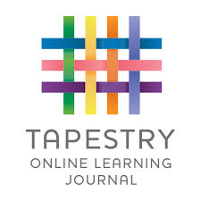

**Cornflour Gloop**

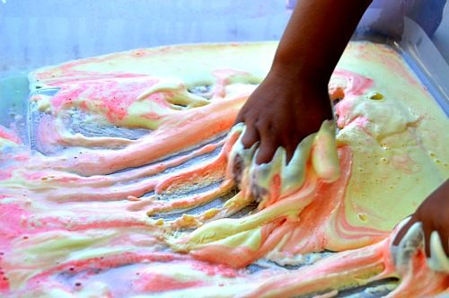

Children love to explore cornflour both dry and mixed with water (beware it is very messy!) Children enjoy the drippy feeling as it runs through their fingers, they can also try and roll it into a ball before if falls into a runny mixture again!

**Shaving Foam**

This works well in a shallow tray and is ideal for children to practise their letter formation, writing their name, writing simple words, writing their numbers, etc...

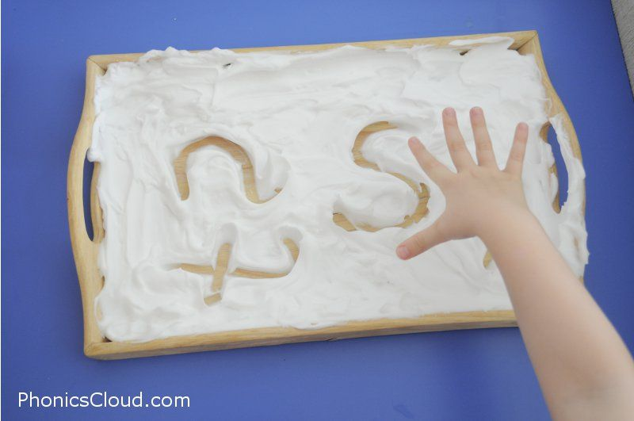

**Playdough** an old classic! You may want to consider adding different colourings or different smells e.g. baby oil, shampoo or tea tree oil.

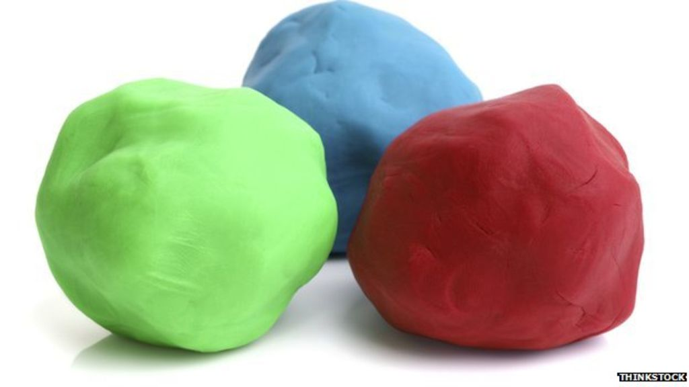

**Recipe**

2 cups of plain flour

Half a cup of salt

2 tablespoons of cooking oil

2 tablespoons of cream of tartar

1 to 1.5 cups of boiling water