**Useful Phonics Websites and Apps**

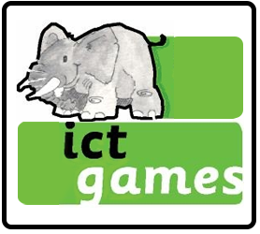

http://www.ictgames.com/literacy.html

Can be used on computers and soon to be

made available on tablets/iPads.

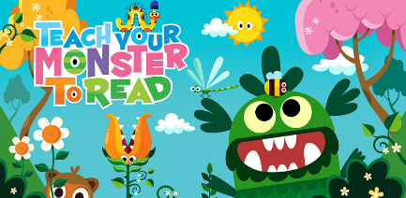

https://www.teachyourmonstertoread.com/

Website is free, just register!

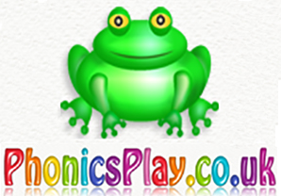

https://www.phonicsplay.co.uk/

freeIndex.htm

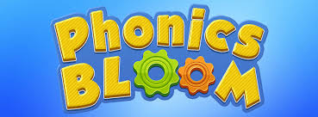

https://www.phonicsbloom.com/

https://www.mrmcmakingmemories.com/



http://www.letters-and-sounds.com/

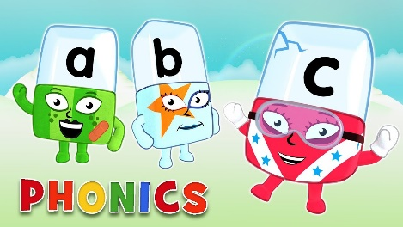

https://www.bbc.co.uk/cbeebies/shows/