What to do today
IMPORTANT Parent or Carer – Read this page with your child and check that you are happy with what they have to do and any weblinks or use of internet.

1. Imagine a character’s questions
- Look closely at Eric’s Questions
- What do you think he might be asking? Can you think of three possible questions for each of these pictures?
- If you would like to, watch the story again using the PowerPoint: Eric or watch Ruth Merttens reading the book https://www.youtube.com/watch?v=H71F0-_QrpE
2. Remind yourself about Pronouns and Determiners
- Use the PowerPoint on Pronouns and Determiners. If this is not possible, use the Revision Card to remind yourself about these.
- Complete Pronouns and Determiners Practice.

3. Now for some writing
- Use words and pictures on the Planner to imagine a day out for Eric.
- Write about the day out, using pronouns and determiners for cohesion.

Well done! Share your writing with a grown-up. Show them some of the pronouns and determiners that you have used.

Try the Fun-Time Extras
- Look at the Endpapers. These are Shaun Tan’s drawings that he puts at the start and finish of his books. What is your favourite drawing? Could you make up a story about it?
- Could you make your own collection of sketches in this style?

Eric’s Questions

What might Eric be asking?

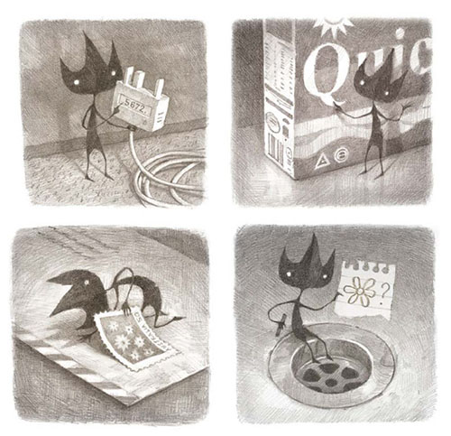
From Eric by Shaun Tan
Revision Card – Pronouns and Determiners

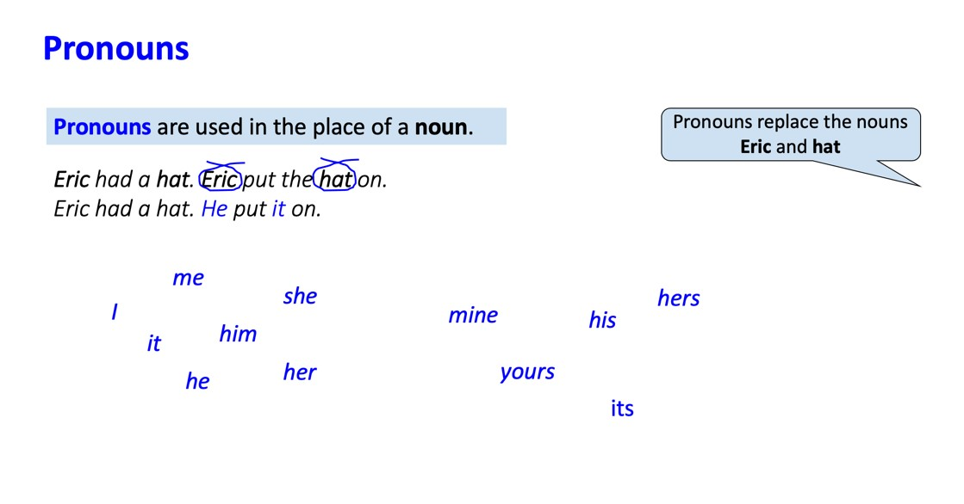 | 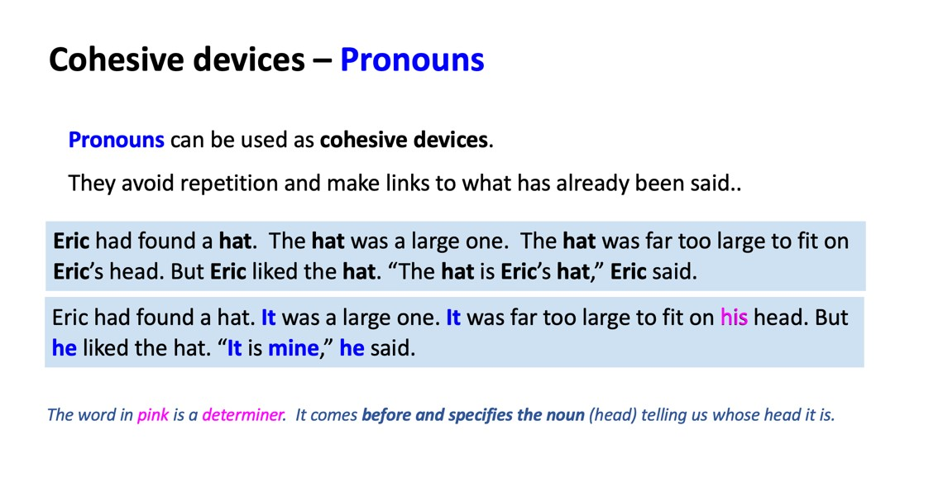
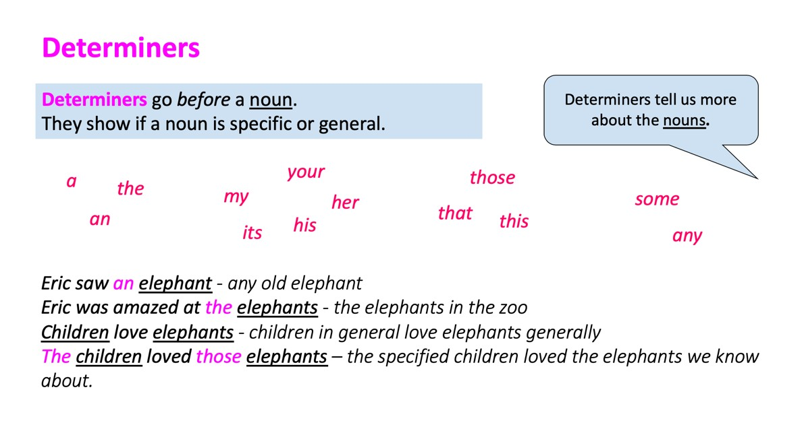 | 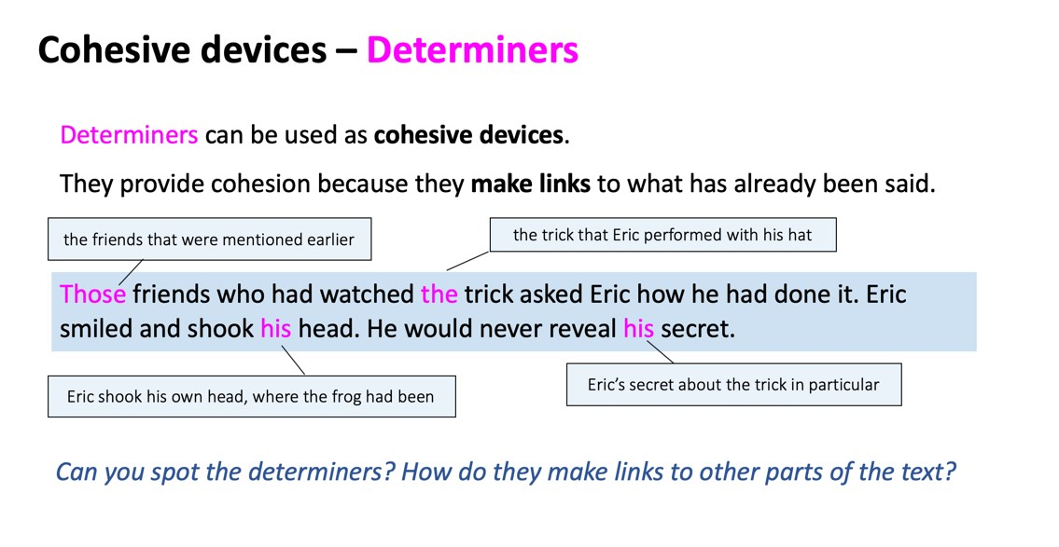

Pronouns and Determiners Practice
Now write a short paragraph containing exactly 15 pronouns/determiners.

A Check your understanding

Identify the pronouns and determiners in these sentences. Underline them in two different colours.

- We went to the zoo to see some animals.
- Eric took a small packed lunch and I brought mine.
- My lunch was the thing Eric was most interested in. He examined my sandwiches.
- I did not see his. He kept it wrapped up in a tight package.
- It must be a cultural thing, my mum thought.

B Explore cohesion using pronouns

Rewrite this extract, replacing the pronouns with nouns. How does it sound when you read it back?

Secretly I had been looking forward to having a foreign visitor - I had so many things to show him. For once I could be a local expert, a fountain of interesting facts and opinions.
Fortunately, Eric was very curious, and he always had plenty of questions.
However, they weren’t the kind of questions I had been expecting. Most of the time I could only say, ‘I’m really not sure’ or ‘That’s just how it is!’

C Explore cohesion using determiners

Think of unexpected questions Eric might ask about the objects. Write them, using determiners to specify more about the nouns, e.g. What would happen if I told this disk a secret? Do these snacks enjoy the film?

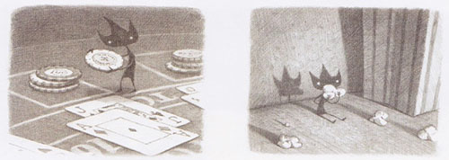

D Imagine a day out with Eric

Imagine you took Eric out for the day. Think about what you might do and how he might surprise you.

Planner: Eric’s Day Out

Eric’s Day Out

Endpapers

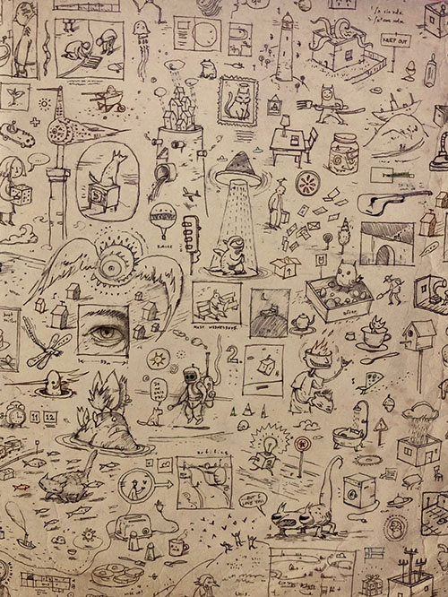

Pronouns and Determiners Practice - Answers
Now write a short paragraph containing exactly 15 pronouns/determiners.

A Check your understanding

Identify the pronouns and determiners in these sentences. Underline them in two different colours.

- We went to the zoo to see some animals.
- Eric took a small packed lunch and I brought mine.
- My lunch was the thing Eric was most interested in. He examined my sandwiches.
- I did not see his. He kept it wrapped up in a tight package.
- It must be a cultural thing, my mum thought.

B Explore cohesion using pronouns

Rewrite this extract, replacing the pronouns with nouns. How does it sound when you read it back?

Secretly I had been looking forward to having a foreign visitor - I had so many things to show him. For once I could be a local expert, a fountain of interesting facts and opinions.
Fortunately, Eric was very curious, and he always had plenty of questions.
However, they weren’t the kind of questions I had been expecting. Most of the time I could only say, ‘I’m really not sure’ or ‘That’s just how it is!’

Secretly Shaun had been looking forward to having a foreign visitor - Shaun had so many things to show the foreign visitor. For once Shaun could be a local expert, a fountain of interesting facts and opinions.
Fortunately, Eric was very curious, and Eric always had plenty of questions.
However, the question weren’t the kind of questions Shaun had been expecting. Most of the time Shaun could only say, ‘Shaun is really not sure’ or ‘That’s just how the situation is!’

C Explore cohesion using determiners

Think of unexpected questions Eric might ask about the objects. Write them, using determiners to specify more about the nouns, e.g. What would happen if I told this disk a secret? Do these snacks enjoy the film?
Examples

Why is this bottle-lid crinkly round the edges? Why isn’t it smooth?
Why are some things wrapped in plastic? Why is this wrapper on the ground? What was in it?

