What to do today
IMPORTANT Parent or Carer – Read this page with your child and check that you are happy with what they have to do and any weblinks or use of internet.

1. Read a poem
- Read Jack and the Beanstalk. Read it in your head and then read it out loud. Can you find the rhythm of the poem?
- Follow the words as you watch this video of the poem. What do you think are the good points of this performance?
https://www.youtube.com/watch?v=DLcU650GcjY

2. Remind yourself about noun phrases
- Use the PowerPoint on noun phrases or, if this is not possible, remind yourself of these using the Revision Card.
- Complete Expanded Noun Phrases. Rewrite each sentence, expanding the noun phrase so that it has more information.

3. Now for some writing
- Use the Planner to show this version of Jack and the Beanstalk in words and pictures.
- Now write the story. Try to include as much humour as you can.

Well done! Share your writing with somebody else. Which parts of your story did they find funniest?

Try the Fun-Time Extras
- Can you practise reading the poem and make a recording of yourself to share with someone else?
- Can you make some illustrations for your favourite parts of the poem?

Jack and the Beanstalk
Roald Dahl

Jack’s mother said, ‘We’re stony broke!
Go out and find some wealthy bloke
Who’ll buy our cow. Just say she’s sound
And worth at least a hundred pound.
But don’t you dare to let him know
That she’s as old as billy-o.’
Jack led the old brown cow away,
And came back later in the day,
And said, ‘Oh Mumsie dear, guess what
Your clever little boy has got.
I got, I really don’t know how,
A super trade-in for our cow.’
The mother said, ‘You little creep,
I’ll bet you sold her much too cheap.’
When Jack produced one lousy bean,
His startled mother, turning green,
Leaped high up in the air and cried,
‘I’m absolutely stupefied!
You crazy boy! D’you really mean
You sold our Daisy for a bean?’
She snatched the bean. She yelled, ‘You chump!’
And flung it on the rubbish-dump.
Then summoning up all her power,
She beat the boy for half an hour,
Using (and nothing could be meaner)
The handle of a vacuum-cleaner.
At ten p.m. or thereabout,
The little bean began to sprout.
By morning it had grown so tall
You couldn’t see the top at all.
Young Jack cried, ‘Mum, admit it now!
It’s better than a rotten cow!’
The mother said, ‘You lunatic!
Where are the beans that I can pick?
There’s not one bean! It’s bare as bare!’
‘No, no!’ cried Jack. ‘You look up there!
Look very high and you’ll behold
Each single leaf is solid gold!’
By gollikins, the boy was right!
Now, glistening in the morning light,
The mother actually perceives
A mass of lovely golden leaves!
She yells out loud, ‘My sainted souls!
I’ll sell the Mini, buy a Rolls!
Don’t stand and gape, you little clot!
Get up there quick and grab the lot!’
Jack was nimble, Jack was keen.
He scrambled up the mighty bean.
Up up he went without a stop,
But just as he was near the top,
A ghastly frightening thing occurred –
Not far above his head he heard
A big deep voice, a rumbling thing
That made the very heavens ring.
It shouted loud, ‘FEE FI FO FUM
I SMELL THE BLOOD OF AN ENGLISHMAN!’
Jack was frightened, Jack was quick,
And down he climbed in half a tick.
‘Oh mum!’ he gasped. ‘Believe you me,
There’s something nasty up our tree!
I saw him mum! My gizzard froze!
A Giant with a clever nose!’
‘A clever nose!’ his mother hissed.
‘You must be going round the twist!’
‘He smelled me out, I swear it, mum!
He said he smelled an Englishman!’
The mother said, ‘And well he might!
I’ve told you every single night
To take a bath because you smell,
But would you do it? Would you hell!
You even make your mother shrink
Because of your unholy stink!’
Jack answered, ‘Well, if you’re so clean
Why don’t you climb the crazy bean.’
The mother cried, ‘By gad, I will!
There’s life within the old dog still!’
She hitched her skirts above her knee
And disappeared right up the tree.
Now would the Giant smell his mum?
Jack listened for the fee-fo-fum.
He gazed aloft. He wondered when
The dreaded words would come . . .
And then . . .
From somewhere high above the ground
There came a frightful crunching sound.
He heard the Giant mutter twice,
‘By gosh, that tasted very nice.
Although’ (and this in grumpy tones)
‘I wish there weren’t so many bones.’
‘By Christopher!’ Jack cried. ‘By gum!
The Giant’s eaten up my mum!
He smelled her out! She’s in his belly!
I had a hunch that she was smelly.’
Jack stood there gazing longingly
Upon the huge and golden tree.
He murmured softly, ‘Golly-gosh,
I guess I’ll have to take a wash
If I am going to climb this tree
Without the Giant smelling me.
In fact, a bath’s my only hope . . .’
He rushed indoors and grabbed the soap
He scrubbed his body everywhere.
He even washed and rinsed his hair.
He did his teeth, he blew his nose
And went out smelling like a rose.
Once more he climbed the mighty bean.
The Giant sat there, gross, obscene,
Muttering through his vicious teeth
(While Jack sat tensely just beneath),
Muttering loud, ‘FEE FI FO FUM,
RIGHT NOW I CAN’T SMELL ANYONE.’
Jack waited till the Giant slept,
Then out along the boughs he crept
And gathered so much gold, I swear
He was an instant millionaire.
‘A bath,’ he said, ‘does seem to pay.
I’m going to have one every day.’

Revision Card – Noun Phrases
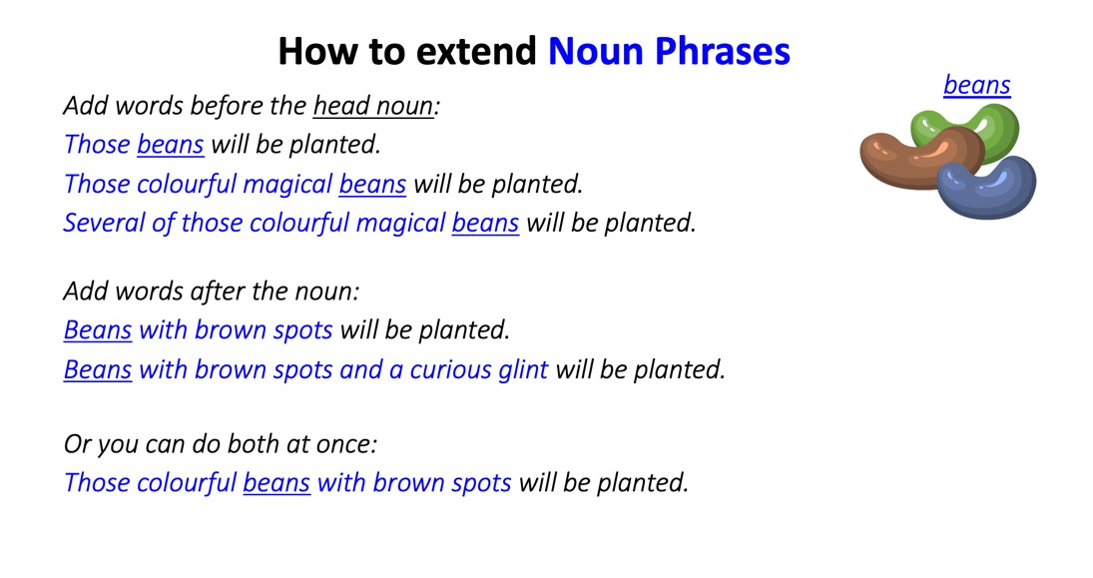
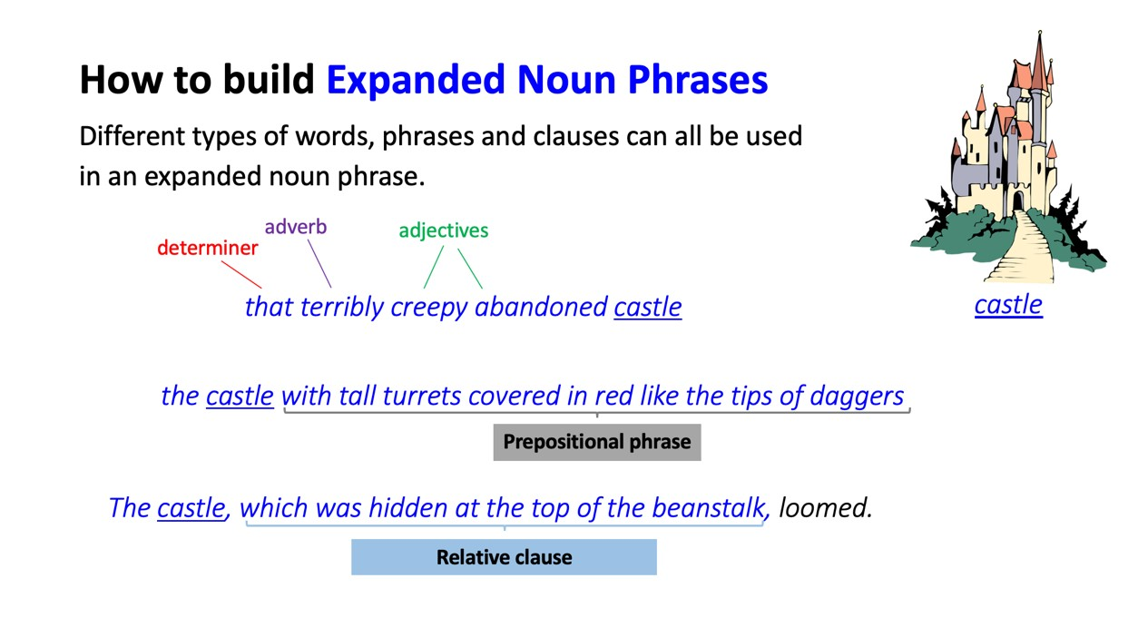
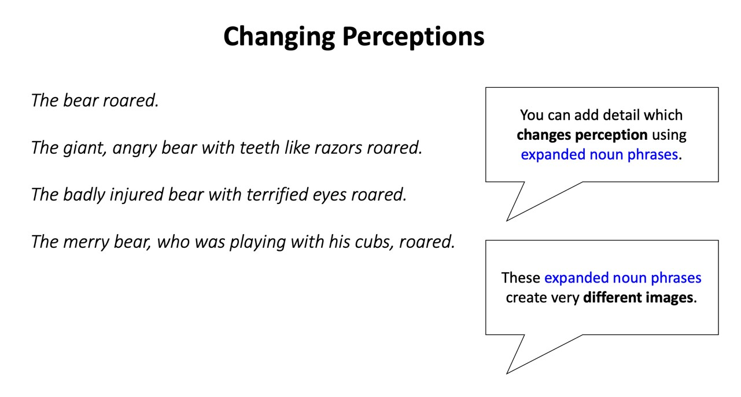

Expanded Noun Phrases

Rewrite each sentence, expanding the noun phrase so that it has more information.

Jack sold the cow.

_________________________________________________________________

Beans grew towards the sky.

_________________________________________________________________

Jack scrambled up the beanstalk.

_________________________________________________________________

Giant muttered through his teeth.

_________________________________________________________________

Giant ate the mother.

_________________________________________________________________

Leaves grew on the beanstalk.

_________________________________________________________________

Mother climbed the beanstalk.

_________________________________________________________________

Goose lays eggs.

_________________________________________________________________

Planner

Jack and The Beanstalk

Write your version of the story here.

