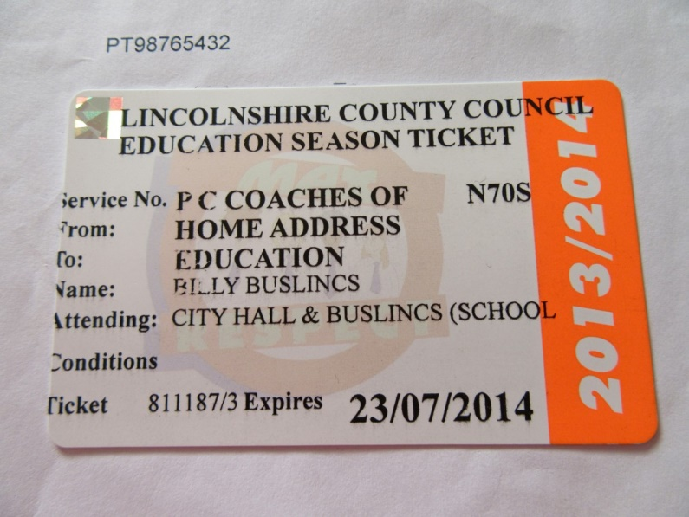
Information for "My Moving On to Secondary School Book"

Bus company and number of you bus. Number will be in windscreen of your bus.

Academic school year
Date your bus pass runs out, it only last one school year.
Name of the school you are going to.
Your name do not let anyone else borrow your bus pass.
Where your bus stop is

Bus passes are free if you are entitled to one you must be going to your nearest school and live 3 miles or more from it. If you lose your bus pass or anything on it cannot be read then please apply for a new bus pass this will cost £5.

Seat belts must be used if they are fitted not all secondary school buses have them you must sit properly in your seats if belts are not fitted.
Don't distract the driver it only takes a second of the driver not concentrating and they could be an accident, the driver's job is to get you to and from school safely. Shouting, moving around the bus, throwing things, loud music all of these are things that can distract the driver.
Walking out from behind a bus means that any other vehicles passing the bus the driver will not see that student in time to avoid them. Two years ago we had two students in Lincolnshire who did this and both lost their lives.

Mobile phones – never use your mobile phone whilst walking on or near the roads, if you must use it find somewhere away from traffic and stand still, better still wait until you are in the car or on the bus, even better still wait until you get home. Especially if you are phoning a friend this means that both of you are probably home and you are not putting you or them at risk.
Need help when travelling – if something is happening on the bus that you know should not then please tell someone, all secondary schools have teachers who are designated to look after the buses make sure you find out who that is in your school. Please report any bad behaviour on the school bus so that it can be stopped as this sort of behaviour puts everyone on the bus and around the bus as risk of being hurt.

Picture below is identical but the child in the bottom picture has taken off the high viz jacket that they were wearing. It shows the children how easy it is for them to not be seen and it doesn’t matter if it is a dull day or a bright summer day. We encourage them to wear bright colours when walking to school or to a bus stop so that drivers can see them. Sometimes they forget that they do not have that adult with them now who usually makes sure they are safe they are now the only ones who can do that and they need to make sure they keep themselves safe all the time.

