What to do today
IMPORTANT Parent or Carer – Read this page with your child and check that you are happy with what they have to do and any weblinks or use of internet.

1. Watch a newspaper article
- Read First News – Frank Mills. Which three facts do you think are most important in this story?
- Read Frank Mills – Questions. Think about your answers and then write them carefully as sentences.

2. Summarise other news stories
- Read Inspired in Lockdown 1.
- Complete Summary Table. The first row has been done for you.
- Challenge yourself to read & summarise Inspired in Lockdown 2.
- Which of these stories do you find most inspirational? Why?

3. Now for some writing
- Look at Example Inspirations and then read Lockdown Inspiration Ideas.
- Write notes about your answers to the questions. Leave out questions that you cannot answer.
- Use your ideas to write a paragraph about Lockdown Inspiration – it could be about someone who has inspired you, something you have done or something that you would like to do.

Well done. Share your writing with someone else. What are they inspired to do?

Try these Fun-Time Extras
- Find out more about Captain Thomas Moore
- Put some of your inspiration ideas into action
- Watch the choir from Inspired in Lockdown 2 tinyurl.com/TWJ-Choir-Youtube
First News – Frank Mills

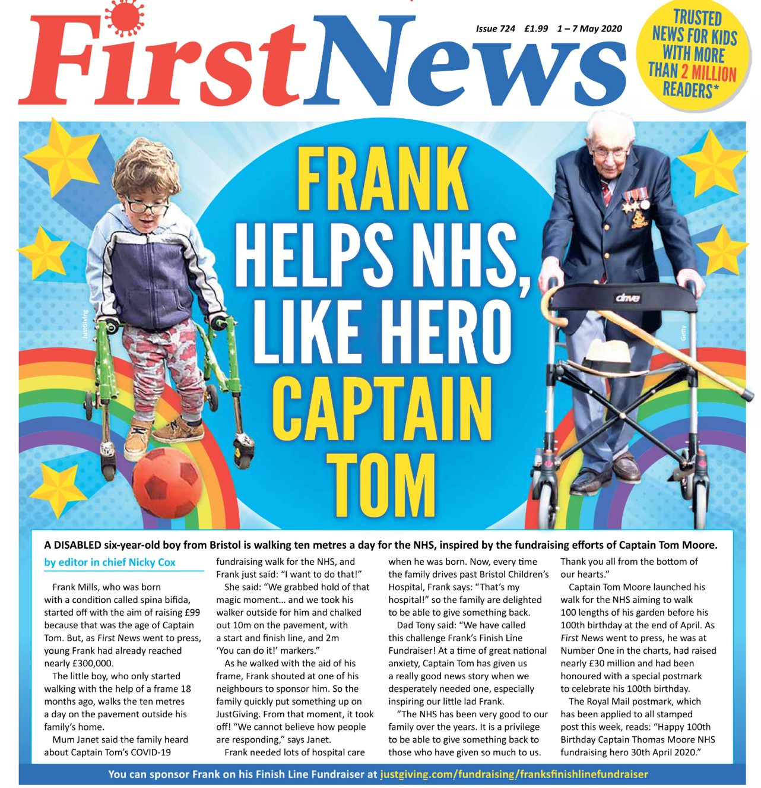

A disabled six-year old boy from Bristol is walking ten minutes a day for the NHS, inspired by the fundraising efforts of Captain Tom Moore.

Frank Mills, who was born with a condition called spina bifida, started off with the aim of raising £99 because that was the age of Captain Tom. But, as First News went to press, young Frank had already reached nearly £300,000.

The little boy, who only started walking with the help of a frame 18 months ago, walks the ten metres a day on the pavement outside his family's home.

Mum Janet said the family heard about Captain Tom's COVID-19 fundraising walk for the NHS, and Frank just said: "I want to do that!"

She said: "We grabbed hold of that magic moment... and we took his walker outside for him and chalked out 10m on the pavement, with a start and finish line, and 2m 'You can do it!' markers."

As he walked with the aid of his frame, Frank shouted at one of his neighbours to sponsor him. So the family quickly put something up on JustGiving. From that moment, it took off! "We cannot believe how people are responding," says Janet.

Frank needed lots of hospital care when he was born. Now, every time the family drives past Bristol Children's Hospital, Frank says: "That's my hospital!" so the family are delighted to be able to give something back.

Dad Tony said: "We have called this challenge Frank's Finish Line Fundraiser! At a time of great national anxiety, Captain Tom has given us a really good news story when we desperately needed one, especially inspiring our little lad Frank. "The NHS has been very good to our family over the years. It is a privilege to be able to give something back to those who have given so much to us. Thank you all from the bottom of our hearts."

Captain Tom Moore launched his walk for the NHS aiming to walk 100 lengths of his garden before his 100th birthday at the end of April. As First News went to press, he was at Number One in the charts, had raised nearly £30 million and had been honoured with a special postmark to celebrate his 100th birthday.

The Royal Mail postmark, which has been applied to all stamped post this week, reads: "Happy 100th Birthday Captain Thomas Moore NHS fundraising hero 30th April 2020."

Frank Mills – Questions

- Who inspired Frank Mills?
- What condition was Frank born with?
- How long has Frank been walking with a frame?
- Find two examples of support that his family gave him.
- Why do you think Frank’s dad says ‘it is a privilege to give something back to the NHS’?
- What was Captain Tom’s original aim?
- Find one example of how Captain Tom has been honoured.
- How would you describe the tone of this article?
9.If you were interviewing Frank, what three questions would you ask?

Inspired in Lockdown 1

Dartmoor Zoo, in Devon, England, launched an appeal to raise money after it had to close last month because of coronavirus. When animal lover Josh White heard, he pledged to climb his stairs 3,400 times, which he says is the equivalent of scaling Mount Everest. The 11-year-old has raised nearly £20,000. | 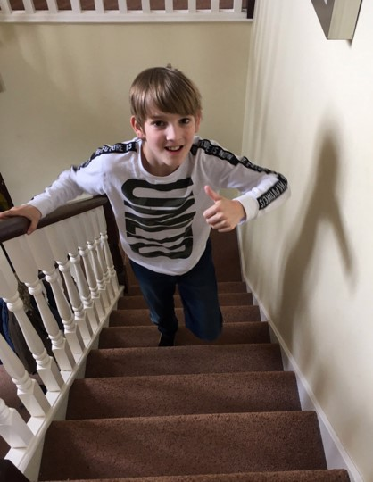
Eight-year-old Elise Parkes and her father spent two days building a Lego model of King’s Mill Hospital, in Nottinghamshire, England. They added figures of doctors, nurses and patients. Parkes was asked by a teacher at her school, Dalestorth Primary School, in Skegby, to make a model of a local building she most admires. | 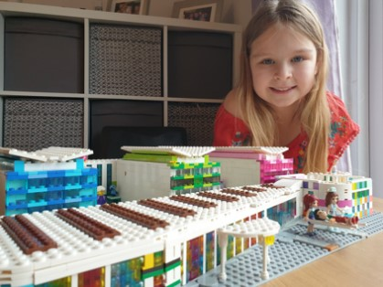
A man living in Eastbourne, England, has spent lockdown completing a fully functioning railway in his back garden. It took Adrian Backshall hundreds of hours to construct the system, which allows a train wagon to be moved up and down. Inside the train, Backshall has a kettle, a seat and a stove, and he says he designed it to host parties for friends. The railway line is just nine metres long, but Backshall hopes to extend it to 15 metres in the future. | 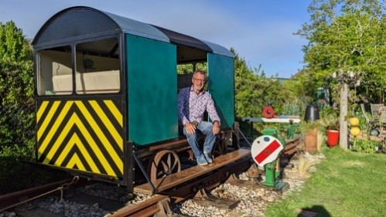
A teacher from London is helping people to learn more about wildlife by writing on the pavement rather than on her blackboard. Rachel Summer usually teaches people about the natural world but this is not possible for now because of the coronavirus outbreak. Instead, she decided to write the names of trees and facts about them on the pavement using chalk, to make people’s walks more interesting. “I wanted to help people make a connection with the wild spaces where they live,” Summer told the BBC. Images of her chalk writings have been posted on social media and have become popular. One user was happy to see them, writing that it made their “heart sing today”. | 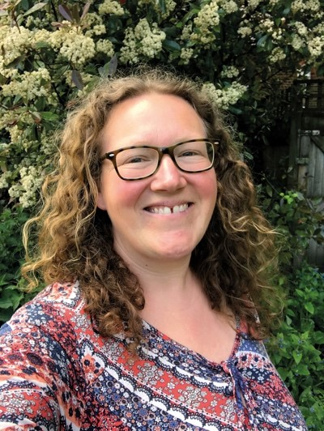

From The Week Junior

Inspired in Lockdown 2

The Islamic holy month of Ramadan began on 23 April. Ramadan marks when the words of the Quran (the Islamic holy book) were first revealed to the Prophet Muhammad, the founder of Islam. This year, Muslims have had to adjust their plans because of the coronavirus outbreak.  During Ramadan, all Muslims who are able to do so take part in a fast (don’t eat) during daylight hours. They do this to bring themselves closer to Allah (God) and to remember those who are less fortunate. They have a meal before dawn called suhoor and another after sunset called iftar. It is normal for family and friends to come together for iftar and go to mosques together for prayer. However, because of coronavirus, mosques around the world are holding worship services and ceremonies online instead.  In the UK, an eight-year-old from Bradford called Yahya Murad Hussain decided to build his own mosque at home using cardboard and sweet wrappers. Yahya says, “I wanted it to be a special area, a peaceful place in the house. It is magical and it makes me feel happy when I go in there.” | 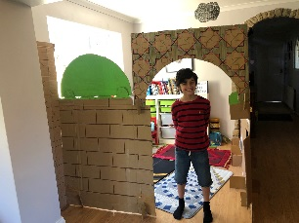
How can a choir sing together when they cannot even be in the same room as each other? This was the question that music teacher Jessie Reeves faced when the coronavirus lockdown was announced. Thankfully, Reeves found a way to connect with her pupils, and she has produced an uplifting video of them all singing.  “We love singing together at school,” Reeves told The Week Junior. “But this is obviously something which is very difficult to do from isolation.” Reeves wanted to make sure her pupils could carry on enjoying music, so she came up with the idea of a virtual choir. She sent a message to other teachers about the idea and the project grew to include 60 young people aged five to 15 years old.  Reeves chose a song by Emeli Sandé called You Are Not Alone and adapted the lyrics for the current situation. Reeves had tried to get groups to sing at the same time through a video-call app, but people’s different internet speeds made it very difficult to keep time with the music. However, Reeves was determined to make it work because she says music can make people feel better. “Sometimes things are hard to talk about, but the music can make it easier to express,” she said. So, Reeves recorded herself singing the song and then she sent it to all the young people. They sang along to Reeves’s track while recording themselves, and sent it back to her. The next part was the hardest for Reeves, who had to learn how to edit all the individual singers together to make one song. She managed it, though, and the video has been viewed more than 3,000 times on YouTube.  “It would be amazing if Emeli Sandé saw the video,” Reeves said. “We think she’d like it.” Reeves hopes the choir can meet up in person in the future. You can watch the video here at tinyurl.com/TWJ-Choir-Youtube | 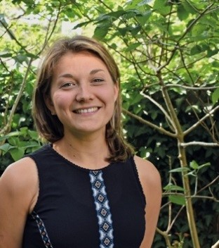

From The Week Junior

Summary Table

Name | Inspiration/Challenge | Action | Results
Josh White | Raise money for Dartmoor Zoo | Climb stairs 3,400 times | Raised £20,000

Example Inspirations

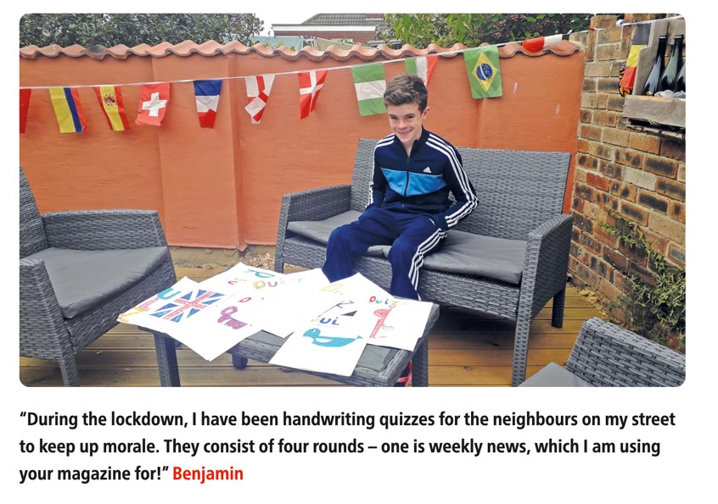
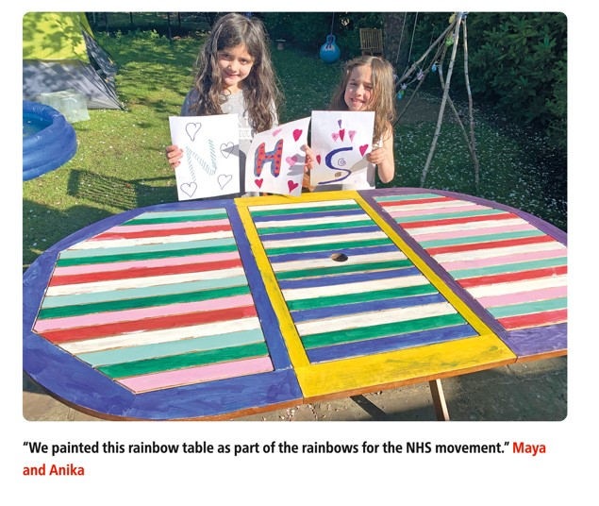
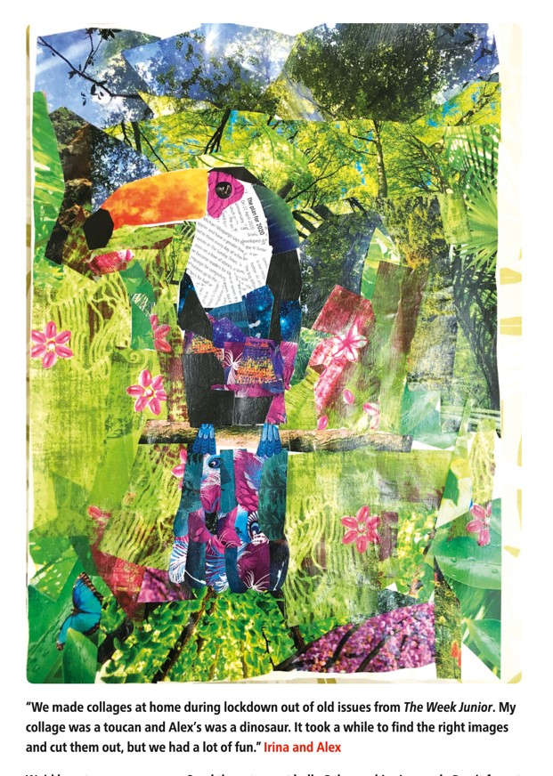

Lockdown Inspiration Ideas

Who?
Who has inspired you in lockdown?
What did they do? Why did it inspire you?
What?
What have you done that you are proud about?
What would you still like to do?

Being Inspired

Use your ideas to write a paragraph about Lockdown Inspiration.

Frank Mills – Questions – Possible Answers

- Who inspired Frank Mills?
Frank was inspired by Captain Tom Moore.
- What condition was Frank born with?
Frank was born with spina bifida.
- How long has Frank been walking with a frame?
Frank has been walking with a frame for eighteen months.
- Find two examples of support that his family gave him.
They chalked a course. They set up a Just Giving page.
- Why do you think Frank’s dad says ‘it is a privilege to give something back to the NHS’?
He is so grateful to the NHS and everyone who has helped his son over the years and so he is glad to be able to do something in return.
- What was Captain Tom’s original aim?
Captain Tom aimed to walk 100 lengths of his garden before his 100th birthday.
- Find one example of how Captain Tom has been honoured.
A special birthday postmark was created for Captain Tom.
- How would you describe the tone of this article?
The tone is positive and celebratory.

