What to do today
IMPORTANT Parent or Carer – Read this page with your child and check that you are happy with what they have to do and any weblinks or use of internet.

1. Listen to a story
- Look carefully at Sinbad Illustration. What do you notice? What could be happening here? Who might the man be? What might be in the pot?
- Listen to the second part of Sinbad’s Fifth Voyage
https://www.youtube.com/watch?v=F-3PjZu_5WY
Start the story at 6:00 and stop it at 11:14
- What did you find out about the Sinbad Illustration?

2. Retell the story
- Use Story Summary to retell the story in four parts.
- Write 2/3 sentences for each box. Try to make your sentences clear and interesting. Draw pictures to illustrate the last two summaries.

3. Remind yourself about phrases and prepositions
- Use the PowerPoint from Slide 7 to the end to remind yourself about phrases and prepositions. If this is not possible, read the Revision Card very carefully.
- Complete Phrase or Clause?
- Complete Expanding Noun Phrases.

Well done. Show your writing to a grown-up. Show them the prepositions that you have used to link phrases to clauses.

Try the Fun-Time Extras

Use your Story Summary to help you practise telling the story of Sinbad and the Old Man. Watch how Wilf tells the story and see if you can tell it just as expressively.

Sinbad Illustration
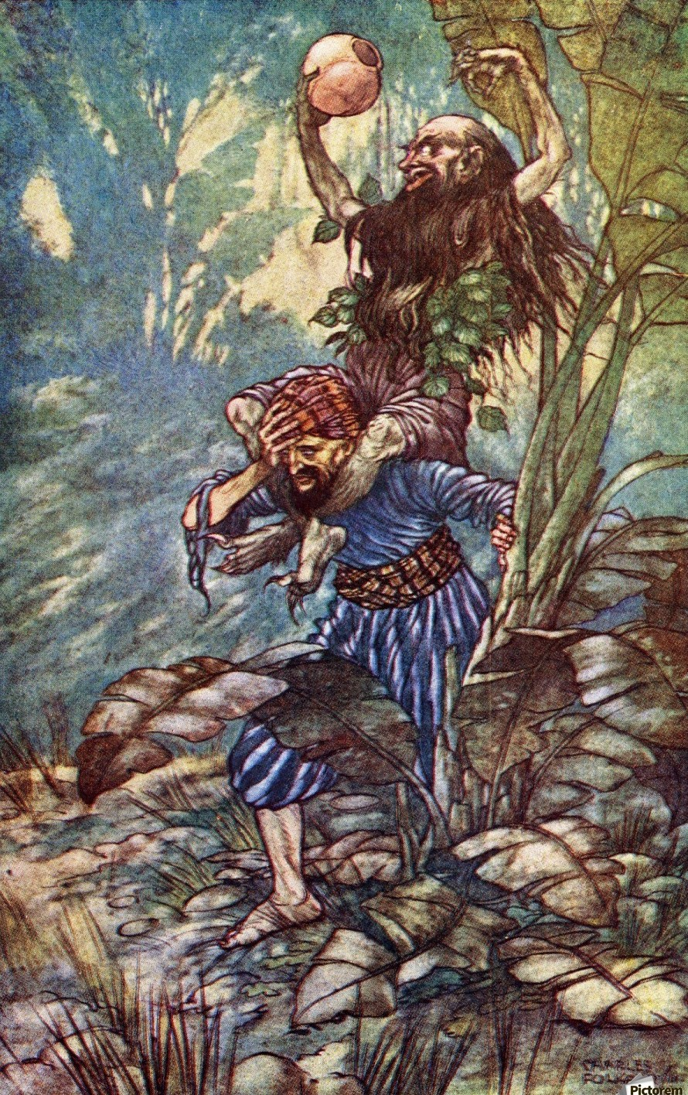

Story Summary

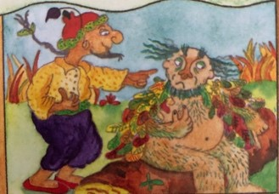 | _____________________________________  _____________________________________  _____________________________________  _____________________________________  _____________________________________  _____________________________________
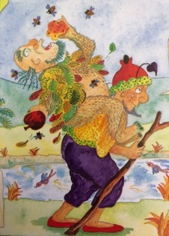 | _____________________________________  _____________________________________  _____________________________________  _____________________________________  _____________________________________  _____________________________________
Draw picture | _____________________________________  _____________________________________  _____________________________________  _____________________________________  _____________________________________  _____________________________________
Draw picture | _____________________________________  _____________________________________  _____________________________________  _____________________________________  _____________________________________  _____________________________________

Revision Card – Prepositions

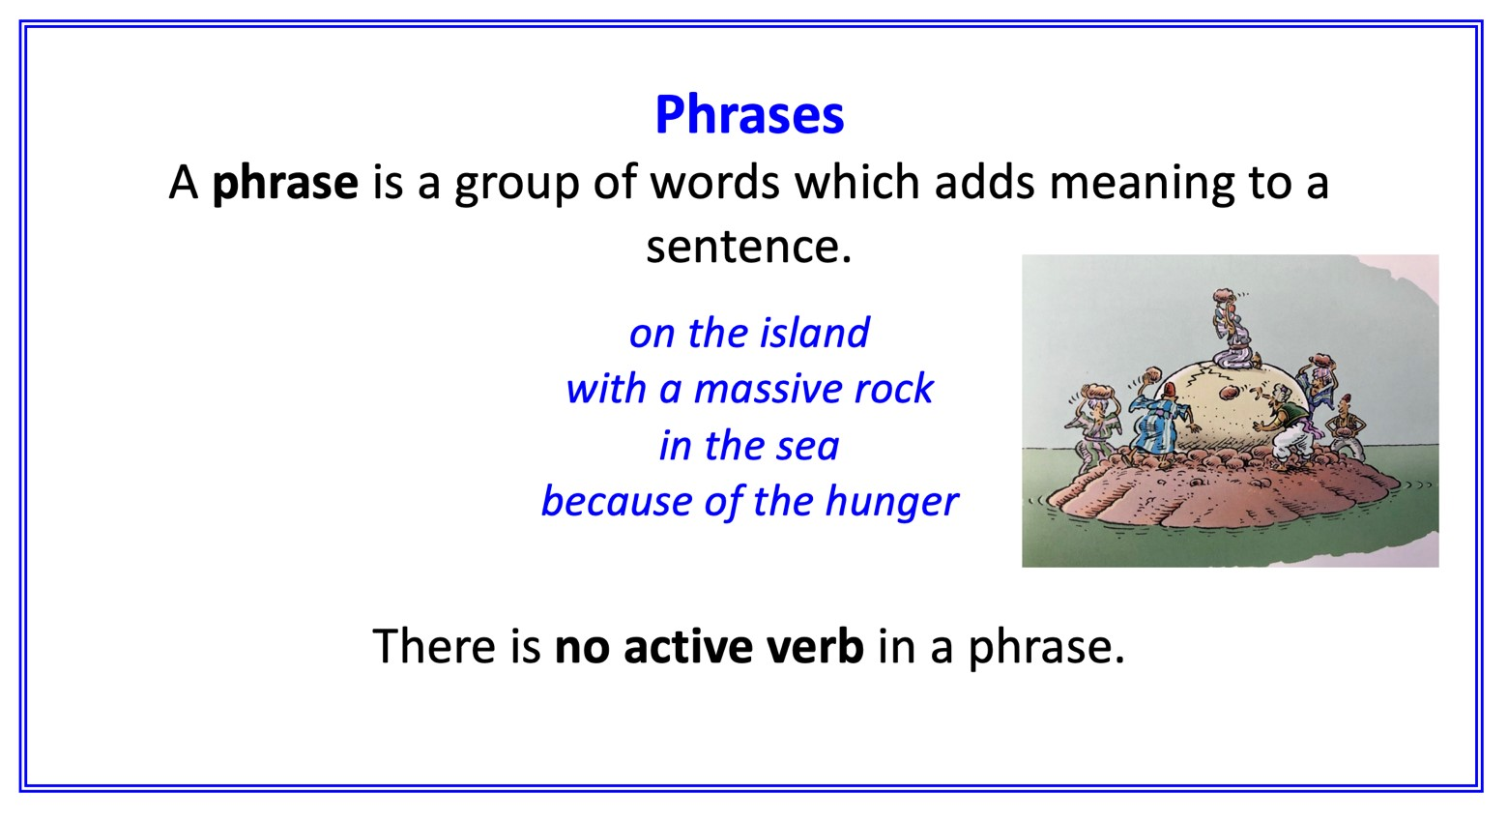
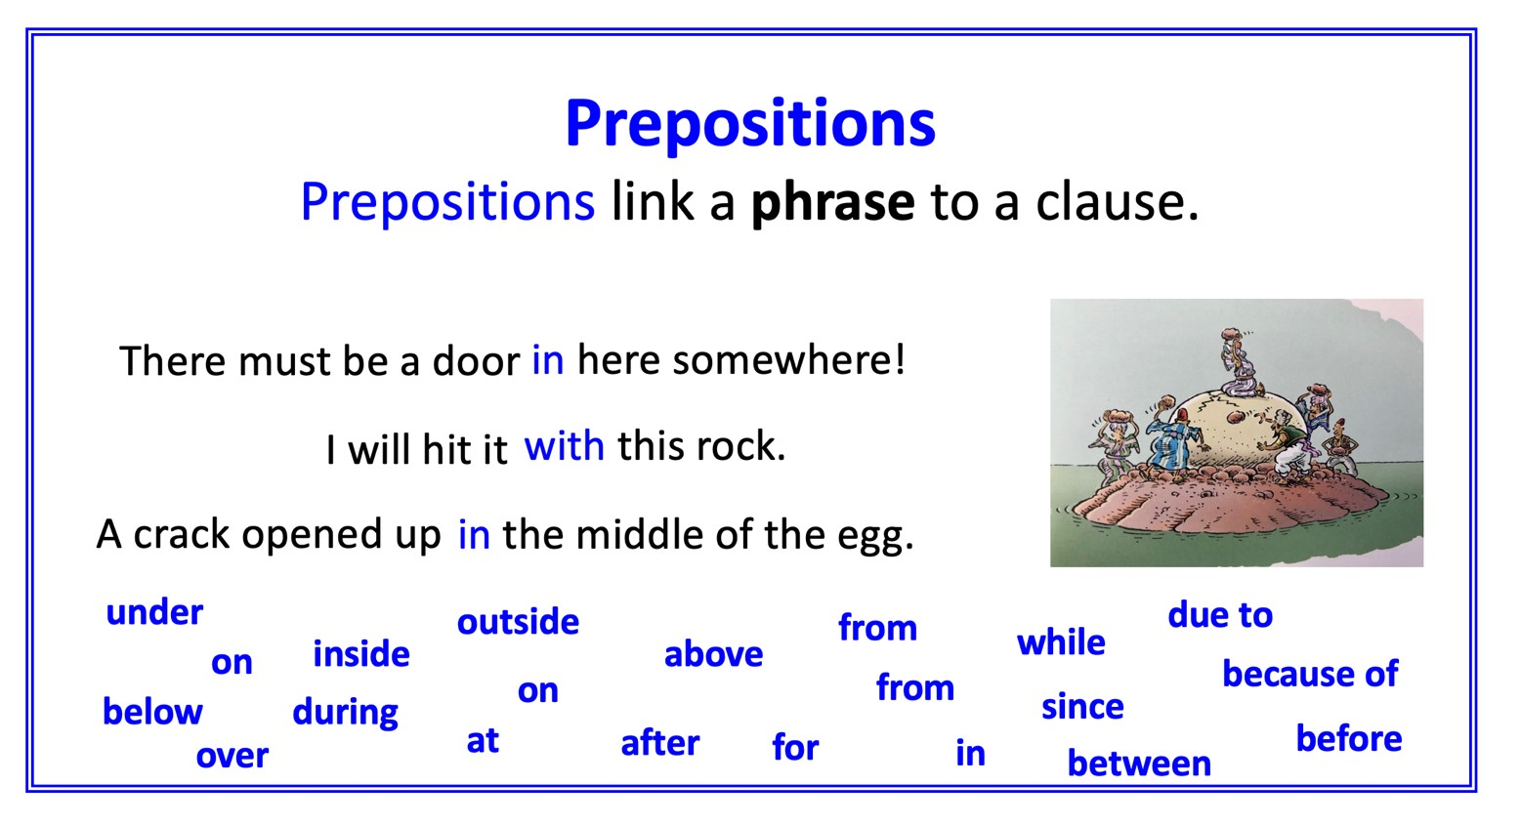

Phrase or Clause?

Write whether the underlined words are a phrase or a clause.

- I found myself in a kind of paradise.

- A mossy bank was my pillow for the night, by the side of a stream.

- He made signs, as if begging me to pick him up on my shoulders.

- I waded across the water and then I knelt down to let him clamber back onto the ground.
- I was finding it hard to breath, and for a moment the world went black to me.
- He pointed for me to take him among the fruit trees, so that he could reach up and grab whatever he wanted to take and eat.
- If ever I refused to do his bidding, he beat or strangled me into submission.
- For some days, I carried my burden around the island.

Expanding Noun Phrases
Choose prepositions and add phrases to these noun phrases.
The first has been done for you.

a wild and raging sea with waves as high as houses
a beautifully calm island
a sad old man
the devious trick
his powerful legs
his endless commands
a clever idea
a calabash full of wine
an enormous gulp
the lucky escape

Prepositions
with, of, by, from, on, under, below, between, inside, next to, over, by, in

Phrase or Clause? - ANSWERS

Write whether the underlined words are a phrase or a clause.

- I found myself in a kind of paradise. PHRASE

- A mossy bank was my pillow for the night, by the side of a stream. PHRASE

- He made signs, as if begging me to pick him up on my shoulders. CLAUSE

- I waded across the water and then I knelt down to let him clamber back onto the ground. CLAUSE
- I was finding it hard to breath, and for a moment the world went black to me. CLAUSE
- He pointed for me to take him among the fruit trees, so that he could reach up and grab whatever he wanted to take and eat. PHRASE
- If ever I refused to do his bidding, he beat or strangled me into submission. CLAUSE
- For some days, I carried my burden around the island. PHRASE

