What to do today
IMPORTANT Parent or Carer – Read this page with your child and check that you are happy with what they have to do and any weblinks or use of internet.

1. Watch the video-message again
- Watch Laura Smyth’s message again. What do you notice new when you watch it this time?
https://www.youtube.com/watch?v=B4lraxptJjs *
- Look at the Film-Stills. Where in the message do you think these come? What emotions do you think that Laura is showing in each of these stills?

2. Investigate emotions
- Read Emotion Words. Circle and then find out about five words that you don’t know. You could use a book dictionary or this online dictionary:
https://kids.wordsmyth.net/we/
- Write definitions in your own words.
- Choose and write 3-5 Emotion Words for each of the pictures on Film-Stills.

2. Write and perform your own message
- Choose three of your ideas from Day 1.
- Try speaking about them out loud. Then write a Script to use.
- Perform your script. Make a recording if you can and plan to watch it again in six months’ time.

Try this Fun-Time Extra
Share your message with others. Ask them what they would include in their own messages. Maybe they can record one too?

*This video is opens with the line, ‘Pity about the weight gain…’ so if you want to avoid this, start at 13 seconds in.

Film Stills

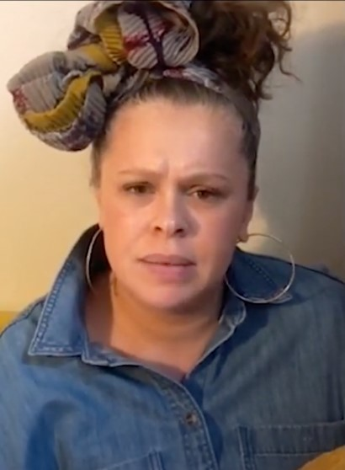

Emotion Words

abashed, admiring, adoring, anxious, apologetic, appalled, appreciative, apprehensive, ardent, ashamed, attached, attentive, awful, awkward, baffled, bashful, befuddled, belittled, buoyant, careful, cautious, chagrined, chaotic, chastened, cheerful, cheerless, defeated, defensive, dejected, delighted, demoralized, depreciated, distressed, disturbed, dizzy, doting, down, downcast, downhearted, dry, ebullient, ecstatic, elated, elevated, embarrassed, fearful, fed-up, feeble, fervent, fidgety, fine, finished, flawed, flustered, foggy, gratified, grim, grouchy, guilty, horrified, hostile, huggy, humble, humiliated, ill-tempered, impatient, imperfect, incapable, incensed, insignificant, insulated, jovial, judged, jumpy, keen, kind, kind-hearted, lacking, left-out, leftover, let-down, light-hearted, marooned, meek, melancholy, merry, miffed, minimized, miserable, moody, morose, mortified, neglected, nervous, offended, outcast, outraged, overjoyed, overwhelmed, panicky, partial, passionate, rattled, ratty, reeling, regretful, rejected, remorseful, rueful, ruined, satisfied, scared, scorned, seething, serene, shaky, shamed, shamefaced, sheepish, shocked, shy, sympathetic, taken-aback, taut, tearful, tender, tense, terrified, terror-stricken, trusting, uncertain, uncherished, uncomfortable, unconvincing, vengeful, vibrant, vindictive, warm-hearted, watchful, weak, weepy, wired, wishful, withdrawn, woeful, worried, worshipful, worthless, wounded, wrecked, yielding, zealous.
Script

Write your script here.

