Attendance Matters
Attendance at West Grantham C of E Primary Academy is important.
Did you know?
- Attendance of below 90% over five years is equivalent to your child missing half a year of school.

- Attendance below 80% over five years means that your child misses a whole year of school.

- Research suggests that 17 missed school days a year equals a drop in GCSE grade (Department for children, schools and families).

- Only a quarter of pupils will achieve GCSE grades A to C if their attendance is below 90%.
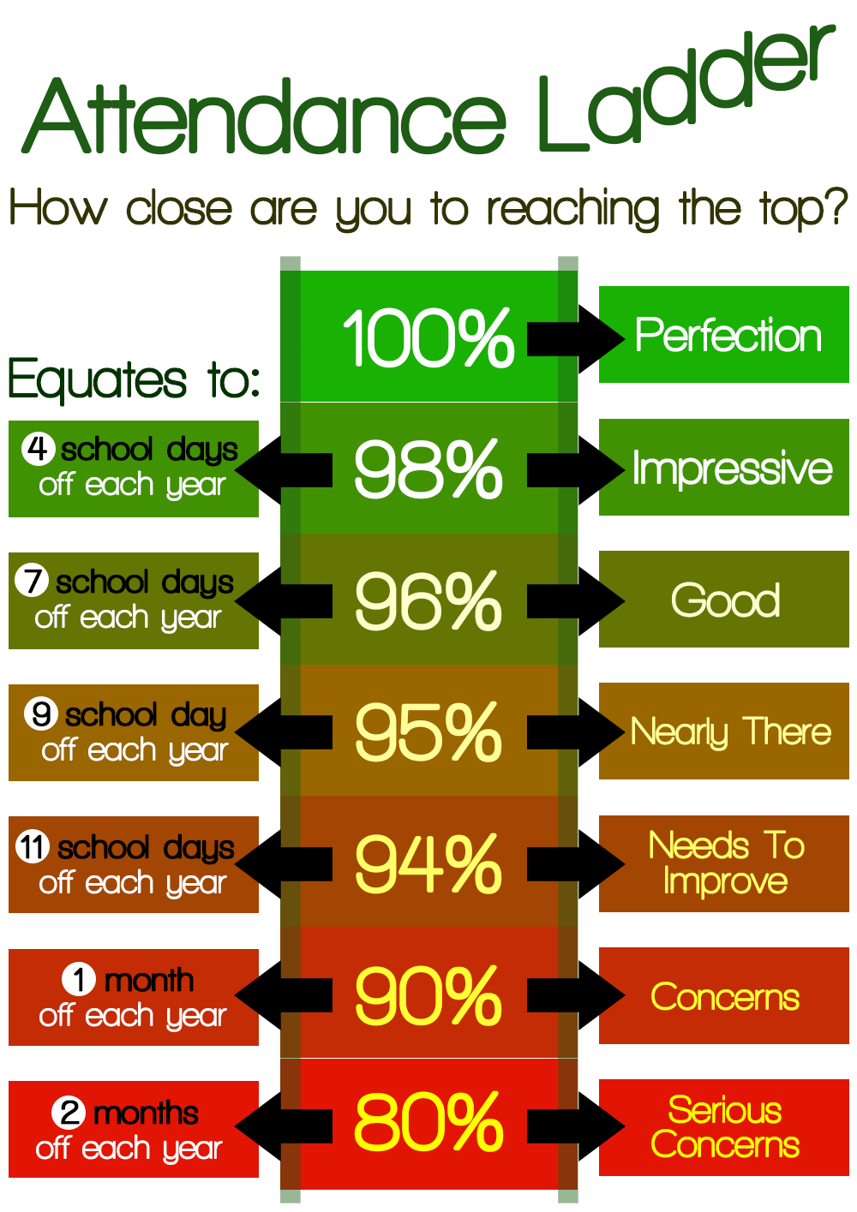

We recognise that there are times when your child might be unwell. Please contact the school as early as possible and let us know, or we will need to contact you. Please contact us every day that your child is not in school, as we must be able to say where the pupil is and that they are safe. We may need medical evidence to authorise the absence. No matter what the problem is causing a student not to attend school, we are here to help.

Our attendance manager is Mrs Bridget Hill. Please contact her if you have any worries around your child’s attendance. Day to day attendance is dealt with by our office staff.

Authorising the absence is at the discretion of the school and we cannot authorise the absence if we do not have a reason why the pupil is not in school or if the reason is not legitimate of the pupils attendance is below 96% and we have not had medical evidence of the ailment,
We are the same as all schools in that we follow Government guidelines and do not authorise holiday leave of absence unless there are exceptional circumstances, and a fixed penalty fine will be levied if the leave of absence is not authorised.
We also reward the good attendance with Attendance Ted spending the week with the class with the best weekly attendance and incentives and rewards for individuals.
Punctuality is also important. Children get to meet their friends at the beginning of the day and need a settled start to be in the best position to learn. Being late for school is like being late for work, it is very unsettling.
Our policy for school attendance and further details is on our school website.
https://www.wgpacademy.org.uk

‘Our mission is to provide outstanding provision for all our pupils and support them through every stage of their journey with us.’

Our mission is to provide outstanding provision for all our pupils and support them through every stage of their journey with us.

